EJ Task Force Feedback

Below are the EJ Task Force’s draft recommendations and other bodies of work to date. Some of the recommendations or bodies of work are in draft phase, while others are “tentatively approved.” Tentative approval means that the recommendation or body of work will appear in the final report, but will need final approval by the Task Force. Members will formally approve recommendations or bodies of work upon adopting the final Task Force report.

Please send feedback by July 27th
Please provide your feedback on the Task Force work to date by Monday, July 27th. Your general feedback, as well as your responses to specific prompts, will directly inform Task Force work. We encourage you to send this form to your communities and colleagues for their input as well.
We have provided prompts for you below as a starting place, but do not let these prompts limit your feedback.
We also encourage you to send along new ideas for draft recommendations, as well as ways to align related recommendations to one another. Staff will synthesize and compile all feedback. Reach out to Elise (elise.rasmussen@sboh.wa.gov) with any questions about this exercise.

Contents
Feedback Process 2
Feedback on Draft Measureable Goals & Model Policy Recommendations 3
Feedback on Draft Community Engagement Subcommittee Recommendations 14
Feedback Prompts for Community Engagement Recommendations: 14
Feedback on Tentatively Approved Mapping Subcommittee Recommendations 15
General Feedback on All Recommendations 20
Tentatively Approved Statewide Definition for EJ 21
Feedback Prompts for the EJ Definition: 21
Draft EJ Principles 22
Feedback prompts for the EJ Principles: 23
Draft Outline: Environmental Justice Task Force (TF) Report 24
Feedback Prompts for the Draft Outline of EJ Task Force Report 25

Feedback Process
The EJ Task Force discussed this feedback process during the June 22 meeting, this is for your reference only. See here for the full Draft Measureable Goals & Model Policy Recommendations presentation.

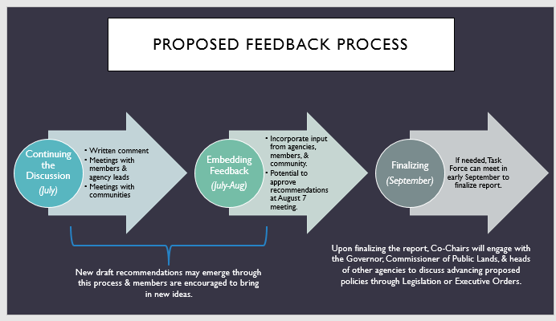

Feedback on Draft Measureable Goals & Model Policy Recommendations
The measureable goals & model policy draft recommendations have NOT been tentatively approved by the Task Force, meaning everything in this section is still up for discussion.
For each draft recommendation please add: your concerns, new ideas, suggestions for improvement, thoughts on how to align recommendations, and areas where you need more clarity.
Below are a set of prompts for feedback. These prompts are meant to guide your thinking, and not meant to box you into filling out a form – respond to the prompts that speak to you, or add your own!
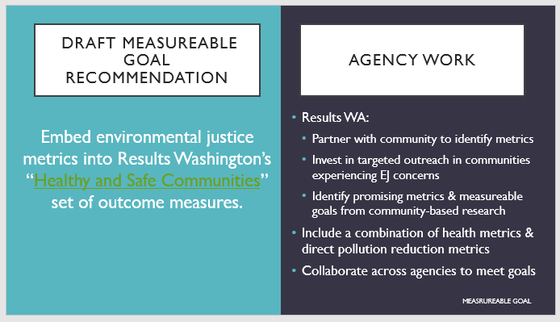
Input your feedback below for the Results WA idea:
- What needs further discussion? Please identify any concerns and provide an explanation.
- If this is a promising draft recommendation, how can we strengthen this idea? Please provide any resources to support refinement of this draft recommendation.
- Who do we need to engage with to further refine this idea?
- What are the potential costs associated with implementing this idea?
- How could this draft recommendation align with other proposed draft recommendations?
- For state agency representatives: What would your agency need in order to implement this idea?
- Any other general comments or feedback?

  - 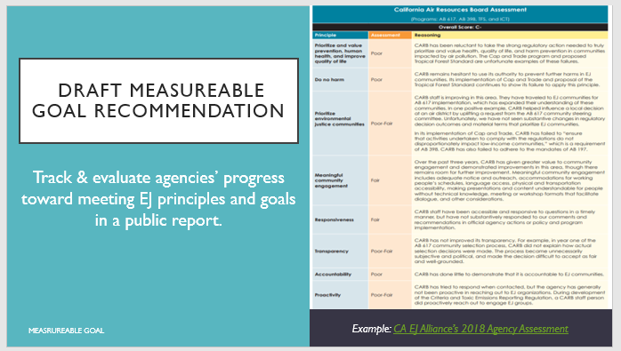
Input your feedback below for the tracking & evaluation idea:
- What needs further discussion? Please identify any concerns and provide an explanation.
- If this is a promising draft recommendation, how can we strengthen this idea? Please provide any resources to support refinement of this draft recommendation.
- Who do we need to engage with to further refine this idea?
- What are the potential costs associated with implementing this idea?
- How could this draft recommendation align with other proposed draft recommendations?
- For state agency representatives: What would your agency need in order to implement this idea?
- Any other general comments or feedback?

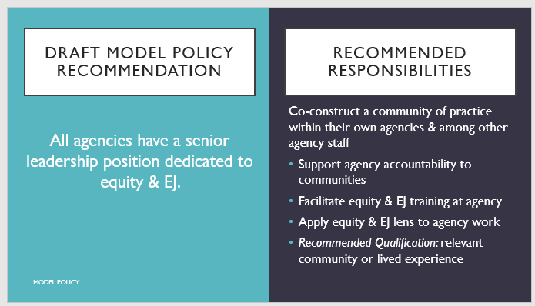
Input your feedback below for the EJ & equity senior leadership position idea:
- What needs further discussion? Please identify any concerns and provide an explanation.
- If this is a promising draft recommendation, how can we strengthen this idea? Please provide any resources to support refinement of this draft recommendation.
- Who do we need to engage with to further refine this idea?
- What are the potential costs associated with implementing this idea?
- How could this draft recommendation align with other proposed draft recommendations?
- For state agency representatives: What would your agency need in order to implement this idea?
- Any other general comments or feedback?

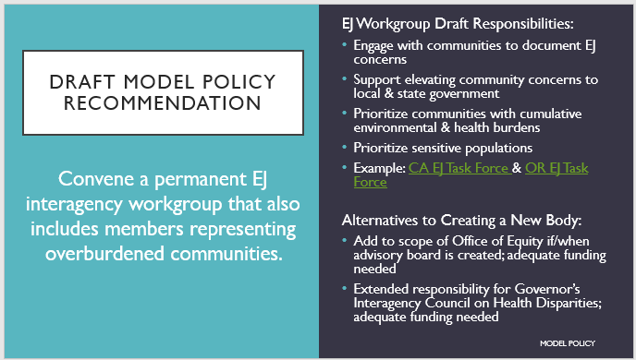
Input your feedback below for the permanent EJ interagency workgroup idea:
- What needs further discussion? Please identify any concerns and provide an explanation.
- If this is a promising draft recommendation, how can we strengthen this idea? Please provide any resources to support refinement of this draft recommendation.
- Who do we need to engage with to further refine this idea?
- What are the potential costs associated with implementing this idea?
- How could this draft recommendation align with other proposed draft recommendations?
- For state agency representatives: What would your agency need in order to implement this idea?
- Any other general comments or feedback?

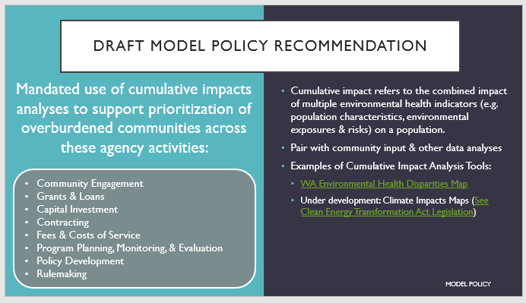
Input your feedback below for the mandated use of cumulative impacts analyses idea:
- What needs further discussion? Please identify any concerns and provide an explanation.
- If this is a promising draft recommendation, how can we strengthen this idea? Please provide any resources to support refinement of this draft recommendation.
- Who do we need to engage with to further refine this idea?
- What are the potential costs associated with implementing this idea?
- How could this draft recommendation align with other proposed draft recommendations?
- For state agency representatives: What would your agency need in order to implement this idea?
- Any other general comments or feedback?

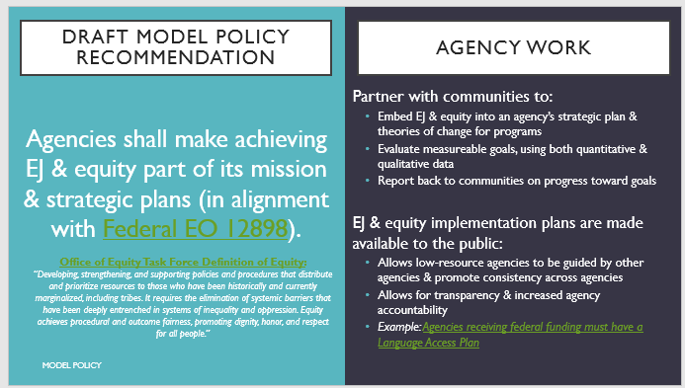
Input your feedback below for integrating the EJ & equity into agency missions (broadly defined) and strategic plans idea:
- What needs further discussion? Please identify any concerns and provide an explanation.
- If this is a promising draft recommendation, how can we strengthen this idea? Please provide any resources to support refinement of this draft recommendation.
- Who do we need to engage with to further refine this idea?
- What are the potential costs associated with implementing this idea?
- How could this draft recommendation align with other proposed draft recommendations?
- For state agency representatives: What would your agency need in order to implement this idea?
- Any other general comments or feedback?

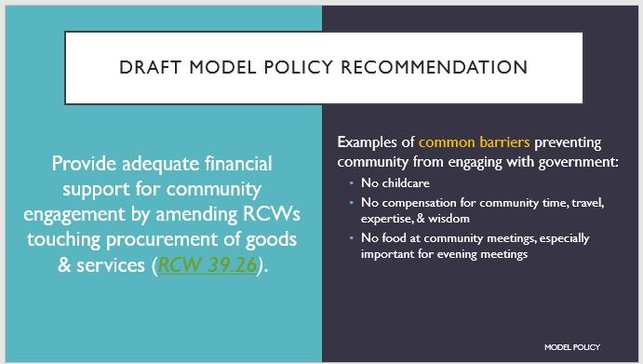
Input your feedback below for the amending RCWs that contribute to community engagement barriers idea:
- What needs further discussion? Please identify any concerns and provide an explanation.
- If this is a promising draft recommendation, how can we strengthen this idea? Please provide any resources to support refinement of this draft recommendation.
- Who do we need to engage with to further refine this idea?
- What are the potential costs associated with implementing this idea?
- How could this draft recommendation align with other proposed draft recommendations?
- For state agency representatives: What would your agency need in order to implement this idea?
- Any other general comments or feedback?

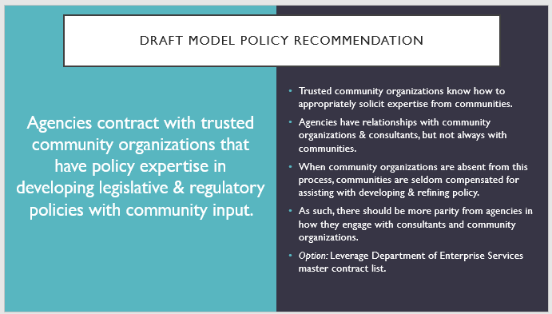
Input your feedback below for the contracting with trusted community organizations idea:
- What needs further discussion? Please identify any concerns and provide an explanation.
- If this is a promising draft recommendation, how can we strengthen this idea? Please provide any resources to support refinement of this draft recommendation.
- Who do we need to engage with to further refine this idea?
- What are the potential costs associated with implementing this idea?
- How could this draft recommendation align with other proposed draft recommendations?
- For state agency representatives: What would your agency need in order to implement this idea?
- Any other general comments or feedback?

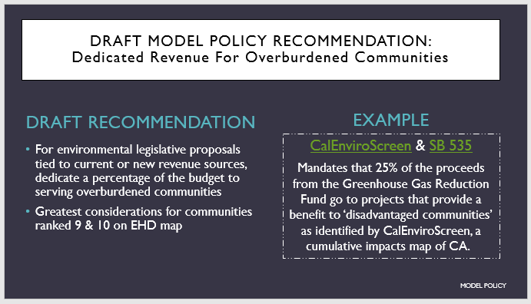
Input your feedback below for the dedicated revenue for overburdened communities idea:
- What needs further discussion? Please identify any concerns and provide an explanation.
- If this is a promising draft recommendation, how can we strengthen this idea? Please provide any resources to support refinement of this draft recommendation.
- Who do we need to engage with to further refine this idea?
- What are the potential costs associated with implementing this idea?
- How could this draft recommendation align with other proposed draft recommendations?
- For state agency representatives: What would your agency need in order to implement this idea?
- Any other general comments or feedback?

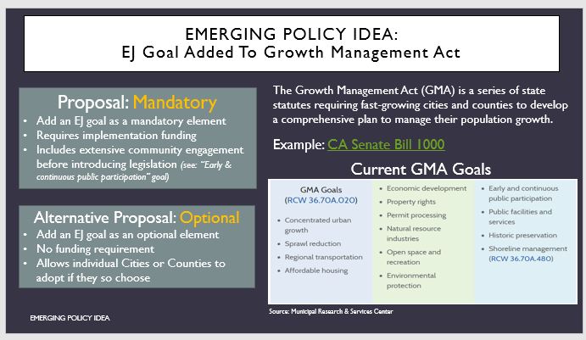
Input your feedback below for the EJ Goal added to GMA idea:
- What needs further discussion? Please identify any concerns and provide an explanation.
- If this is a promising draft recommendation, how can we strengthen this idea? Please provide any resources to support refinement of this draft recommendation.
- Who do we need to engage with to further refine this idea?
- What are the potential costs associated with implementing this idea?
- How could this draft recommendation align with other proposed draft recommendations?
- For state agency representatives: What would your agency need in order to implement this idea?
- Any other general comments or feedback?

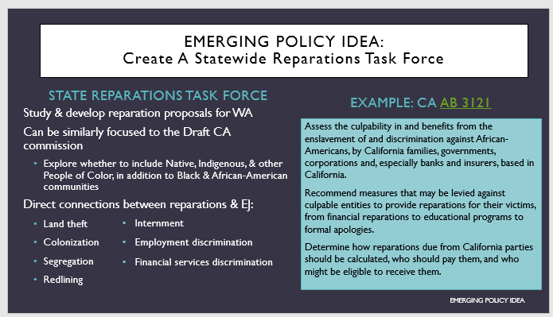
Input your feedback below for the Reparations Task Force idea:
- What needs further discussion? Please identify any concerns and provide an explanation.
- If this is a promising draft recommendation, how can we strengthen this idea? Please provide any resources to support refinement of this draft recommendation.
- Who do we need to engage with to further refine this idea?
- What are the potential costs associated with implementing this idea?
- How could this draft recommendation align with other proposed draft recommendations?
- For state agency representatives: What would your agency need in order to implement this idea?
- Any other general comments or feedback?

Feedback on Draft Community Engagement Subcommittee Recommendations
Link: Presentation with recommendations
Recommendations:
- Tentatively approved at 5/18 Meeting: Each agency develops a community engagement plan, which must include the elements outlined in our Community Engagement Plan guidance.
  - See the Community Engagement Plan guidance document here. The Community Engagement Subcommittee is seeking member feedback on this document as well.
- Agencies use a consistent process to evaluate their services and programs for community engagement. These evaluations weigh the goals, potential for impact, and importance to the community of the service/program, and the makeup of the impacted community. These evaluations determine:
  - The agency’s level of engagement for the project.
  - The potential for outcomes the public can see from their engagement in the process.
Agencies then communicate both determinations in their outreach process.
- When agency decisions have potential to impact a specific community, agencies work with representatives of that community to identify outreach and communication methods.

- Agencies use equity-focused hiring practices and inclusion-focused professional development to build and support an internal staff that represents the cultural and racial makeup of the population they serve.
- Agencies consistently integrate tribal engagement into their outreach work when a program or service has potential to impact Indigenous peoples, Tribal members, or their resources, using tailored approaches based on the needs of the Tribal and or Indigenous community. *Note that engagement is not a substitute for formal government-to-government consultation.
- When agencies ask for representation from a specific geographical or cultural community, the agencies actively support such representation in recognition of the costs of engagement borne by community members. Examples of support include financial compensation, transportation, and food and childcare at meetings.
- Agencies integrate compliance with existing laws and policies that guide community engagement into the budgets of their services and programs:
  - Title VI of the Civil Rights Act, prohibiting discrimination based on race, class, or national origin and requiring meaningful access to people with limited English proficiency
  - Executive Order 05-03 requiring Plain Talk when communicating with the public
  - Executive Order 13166, requiring meaningful access to agency programs and services for people with limited English proficiency.

Feedback Prompts for Community Engagement Recommendations:
- How can we strengthen these recommendations?
- Who do we need to engage with to further refine these recommendations?
- What are the potential costs associated with implementing these recommendations?
- For state agency representatives: What would your agency need in order to implement these recommendations?
- Any other general comments or feedback?

Feedback on Tentatively Approved Mapping Subcommittee Recommendations
The Task Force tentatively approved all Mapping Subcommittee Recommendations on 5/18.
Link: Mapping Recommendations Presentation
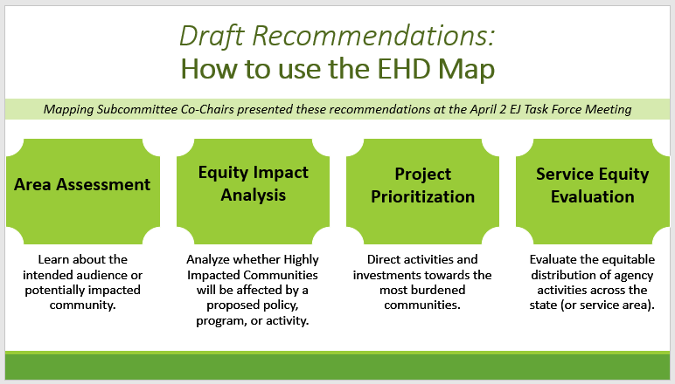
Feedback Prompts for Recommendations on how to use the EHD Map:
- How can we strengthen this recommendation?
- Who do we need to engage with to further refine this recommendation?
- What are the potential costs associated with implementing this recommendation?
- For state agency representatives: What would your agency need in order to implement this recommendation?
- Any other general comments or feedback?

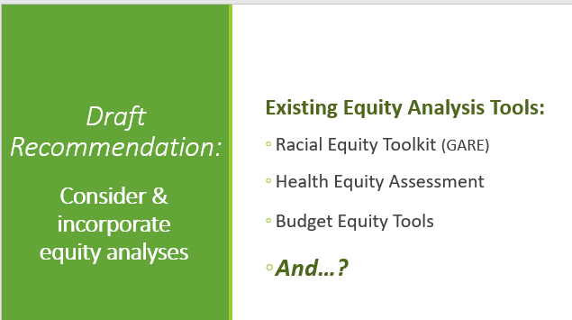
Feedback Prompts for Recommendations on considering & incorporating equity analyses:
- How can we strengthen this recommendation?
- Who do we need to engage with to further refine this recommendation?
- What are the potential costs associated with implementing this recommendation?
- For state agency representatives: What would your agency need in order to implement this recommendation?
- Any other general comments or feedback?

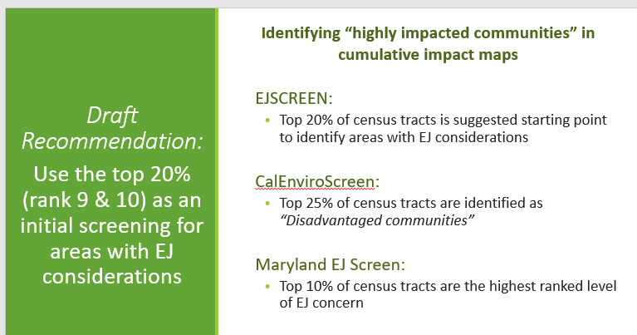
Feedback Prompts for Recommendations on how to identify highly impacted communities:
- How can we strengthen this recommendation?
- Who do we need to engage with to further refine this recommendation?
- What are the potential costs associated with implementing this recommendation?
- For state agency representatives: What would your agency need in order to implement this recommendation?
- Any other general comments or feedback?

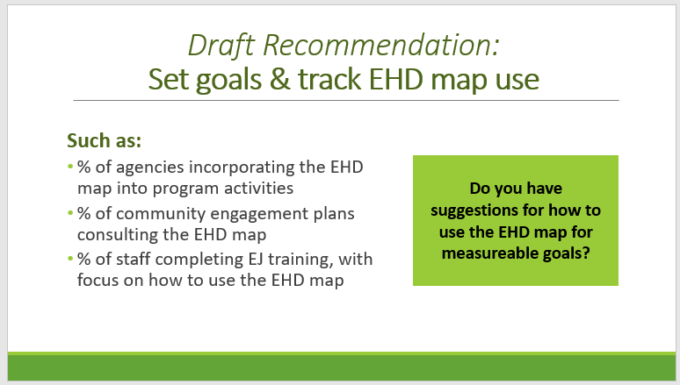
Feedback Prompts for Recommendations on how to set goals & track EHD map use:
- How can we strengthen this recommendation?
- Who do we need to engage with to further refine this recommendation?
- What are the potential costs associated with implementing this recommendation?
- For state agency representatives: What would your agency need in order to implement this recommendation?
- Any other general comments or feedback?

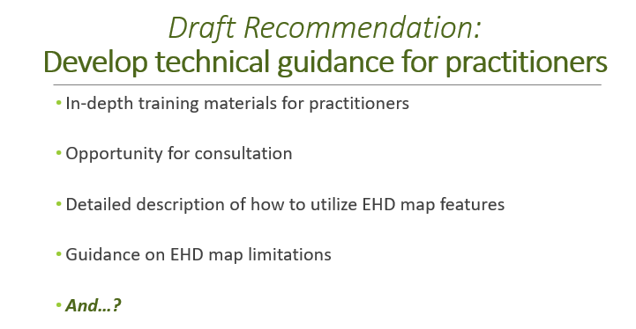
Feedback Prompts for Recommendations on developing technical guidance for practitioners:
- How can we strengthen this recommendation?
- Who do we need to engage with to further refine this recommendation?
- What are the potential costs associated with implementing this recommendation?
- For state agency representatives: What would your agency need in order to implement this recommendation?
- Any other general comments or feedback?

General Feedback on All Recommendations
- What other draft recommendations would you like to bring to the Task Force’s attention? Please provide any research, contacts, or other resources you have to support this recommendation.
- What other general feedback, comments, or questions do you have?
- How can we best package and align promising recommendations to date?

Tentatively Approved Statewide Definition for EJ
The Task Force tentatively approved the statewide definition for EJ on 6/22, with the consideration that the Task Force may expand the demographic categories listed in the first clause of the definition.

Tentatively Approved EJ Definition:
“The fair treatment and meaningful involvement of all people regardless of race, color, national origin or income with respect to development, implementation, and enforcement of environmental laws, regulations and policies including focusing on addressing disproportionate environmental and health impacts by prioritizing highly impacted communities, equitably distributing resources and benefits, and eliminating harm.”

Feedback Prompts for the EJ Definition:
- Should we include other demographic categories in this definition? If so, which ones? If not, why?
- Should we include a broader statement? See example:
“The fair treatment and meaningful involvement of all people regardless of race, color, national origin, income, or any other social identity with respect to development, implementation, and enforcement of environmental laws, regulations and policies including focusing on addressing disproportionate environmental and health impacts by prioritizing highly impacted communities, equitably distributing resources and benefits, and eliminating harm.”
- Note: Staff and Co-Chairs encourage you to think specifically about groups that are most directly burdened by EJ issues.
- Note: The first clause of the statewide definition is the federal EJ definition. In order to ensure state agencies are aligned with the federal definition, we will not change or omit words in the first clause of the statewide definition. You may, however, advocate for adding to the first clause.
  - Federal Definition: “The fair treatment and meaningful involvement of all people regardless of race, color, national origin or income with respect to development, implementation, and enforcement of environmental laws, regulations and policies.”

Draft EJ Principles
The Task Force tentatively approved the bolded headers of the EJ Principles on 6/22.
The following draft EJ Principles were informed by WA communities with recognition and reflection of the Principles of Environmental Justice adopted at the First National People of Color Environmental Leadership Summit in 1991.
Purpose of environmental justice principles:
  - Provide guidance for agencies on how to create & implement EJ goals.
  - Assist with keeping agencies accountable to EJ goals.
  - What else? How could these principles advance the work of your communities, agencies, or organizations?

- Achieve the highest attainable environmental quality and health outcomes for all people.
  - Prioritize health of the land, humans, and animals.
  - Recognize the ecological unity and the interdependence of all species.
  - Ensure the ethical, balanced, and responsible uses of land and resources in the interest of a sustainable Washington.
  - Commit to actions that ensure all children have opportunities to reach their full health and life potential.

- Adopt a racial justice lens.
  - Commit to identifying and disrupting racism embedded in your organization, policies, protocols, practices, and decision-making.
  - Dismantle all forms of racism, including environmental racism, by partnering with communities to eliminate environmental and health disparities for Black people, Native and Indigenous people, and people of color.
  - Develop public policy based on mutual respect and justice for all peoples, free from any form of discrimination or bias.
  - Recognize a special legal and natural relationship of Native Peoples to the U.S. government through treaties, agreements, compacts, and covenants affirming sovereignty and self-determination.

- Engage community meaningfully.
- Prioritize engagement with communities who face environmental injustices and continue to be underinvested and underserved.
- Focus engagement on building long-term, trust-based relationships.
- Fully fund community engagement, community expertise, and community led research.
- Collaborate with communities as equal partners in decision-making, needs assessment, planning, implementation, enforcement, and evaluation to find community driven solutions that are sustainable and amplify community assets.

- Be transparent.
  - Ensure your participation and decision-making processes are equitable and accessible.
  - Make information easily accessible and relevant to the public and ensure communications are culturally and linguistically grounded.
  - Engage community in processes early and often (e.g. planning, funding, policy, evaluation).

- Be accountable.
  - Embed equity and the elimination of environmental and health disparities into mission, planning, goals, and measures of progress.
  - Center the community in identifying the problems, solutions, and successes.
Draft Model Policy Recommendation: Adopt environmental justice principles for policy implementation.

Feedback prompts for the EJ Principles:
- What suggestions for improvement do you have on the sub-sections under each bolded section?
- Do you have additional purposes for EJ principles? See blue box above for list of currently named purposes.
- What feedback do you have on the draft model policy recommendation to adopt EJ principles for policy implementation? See green box above.

Draft Outline: Environmental Justice Task Force (TF) Report
During the May 18th meeting, the EJ Task Force tentatively adopted the section headers of the report (denoted in bold), with the exception of the Glossary section. The subsections within each section will continue to evolve, but we have provided some preliminary placeholders for these subsections for your reference.
*Note: We would like to incorporate community voice throughout the report, which is why you will see “community quote or learning from community…” in each section.
- Executive Summary
  - Community quote or learning from community relevant to this section’s content
  - What the TF is & the purpose of the TF
  - EJ problems in WA – why EJ is needed
    - What does the EHD map really tell us about EJ issues in WA?
    - Acknowledging history & present (e.g. COVID + police brutality) conditions that call for prioritizing EJ in state government
  - EJ principles – still developing; using community feedback to develop principles
  - Summary of process
  - Summary of recommendations
    - WA EJ Definition
- Glossary of EJ and Equity Terms
  - Statement about the power that words have
  - Committed to an asset-based framing throughout the report, and especially when referring to communities
- Story of the TF (background)
  - Community quote or learning from community relevant to this section’s content
  - HEAL Act & creation of the EHD map
- Scoping & interpretation of proviso language
  - Community quote or learning from community relevant to this section’s content
  - Proviso language
- Literature or background research section
  - Community quote or learning from community relevant to this section’s content
  - The history of EJ in WA, and EJ issues in WA communities
  - What other states, local jurisdictions, non-profit organizations, Tribes, etc. are doing to actively combat environmental health disparities and promote improved health outcomes, specifically within an EJ context.
- Process (like a methods section)
  - Community quote or learning from community relevant to this section’s content
  - Subcommittees
  - Community engagement
    - Community engagement process
    - How community informed the recommendations, including lessons learned & partnership with Front & Centered
  - Process for decision making & ensuring representation:
    - One on ones, and other member feedback mechanisms
    - Voting
    - Invitations to join subcommittees and subcommittee meetings
  - Limitations of this process:
    - Time
    - Funding
    - Process did not include all the voices of the people we’re speaking for
    - No tribal representation on the Task Force or Subcommittees
- Learnings & from community
  - Anecdotes and testimonies from communities, highlight what we learned as we visited different areas of the state
  - Look at qualitative data we gathered via listening sessions and community conversations and pull out themes
    - Highlight 3-5 priorities from community
- Recommendations – four separate content areas
  - Mapping Recommendations: Guidance from Mapping Subcommittee
    - How and why the EHD map was created
    - How to use the map
      - Area assessment, equity impact analysis, project prioritization, service equity analysis
      - Strengths and considerations of the map
      - What the map should and should not be used for
        - Practitioner analysis of the map
    - Defining “highly impacted” using the EHD map
    - Measureable goals related to the EHD map: measure the use the map & provide technical guidance
    - Community quote or learning from community relevant to this section’s content
  - Community Engagement Recommendations: Guidance from Community Engagement Subcommittee
    - Key recommendations -- executive summary of guidance document
    - Community quote or learning from community relevant to this section’s content
  - Measureable Goals recommendations
    - Possible: recommendation to use framework for embedding EJ and equity into State agencies (still developing)
    - Community quote or learning from community relevant to this section’s content
  - Model policies recommendations
    - Informed by literature review & subcommittees
    - Policy recommendations
    - EJ Definition
    - EJ Principles
    - Community quote or learning from community relevant to this section’s content
- Minority opinion statements – optional for Task Force members
  - Brief statement representing others’ viewpoints in a recommendation that isn’t unanimous
- References
- Appendices – TBD
  - Community Engagement Subcommittee Guidance document
  - Barriers to public participation – disclaimer: shouldn’t be considered a static list
  - Possibly: existing evaluations of government community engagement work
  - Possibly: Equity and EJ Framework (still developing)

Feedback Prompts for the Draft Outline of EJ Task Force Report
      - What is missing?
      - What is confusing/unclear?
      - Any general feedback?

